8086 16 BIT DIVISION

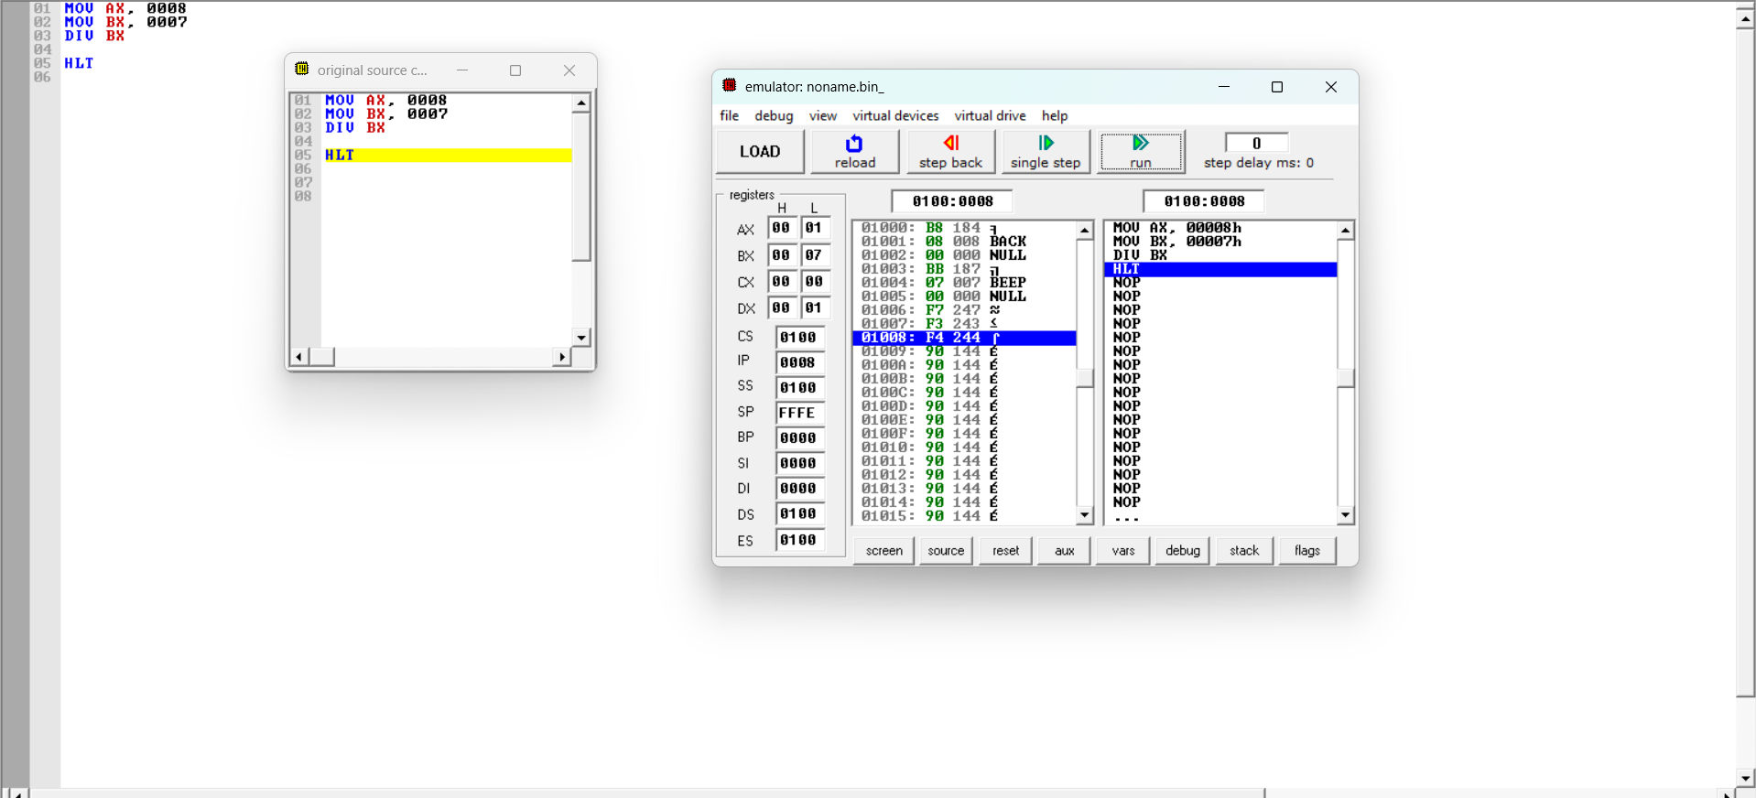W